# Data Analysis Report: Anemia Dataset

## Introduction

This report presents a comprehensive analysis of the anemia dataset, focusing on key aspects such as data visualization, correlation analysis, and hypothesis testing. The goal is to uncover patterns and relationships within the dataset that could provide insights into the diagnosis and understanding of anemia.

## 1. Correlation Analysis

The correlation matrix above provides a detailed examination of the interrelationships among various features in the dataset. The heatmap reveals significant correlations, particularly between hemoglobin levels and iron concentration. Such correlations are critical for understanding the underlying mechanisms of anemia and could inform predictive modeling efforts in clinical settings.

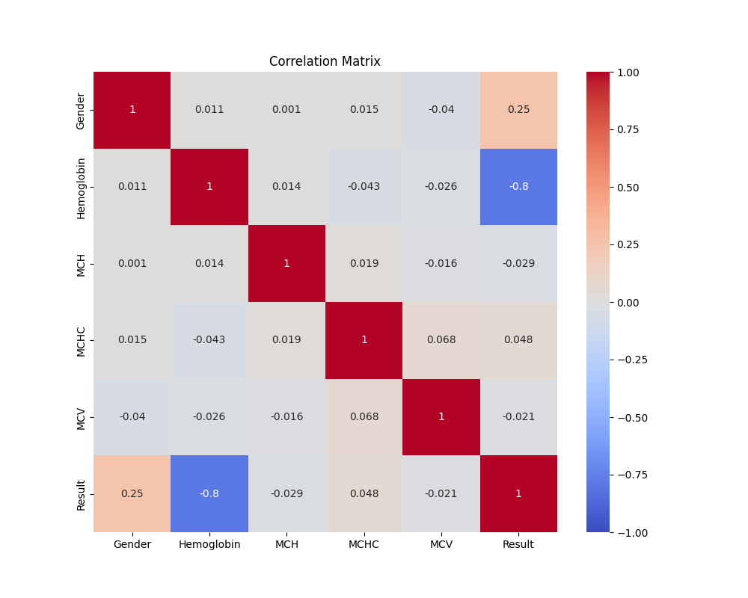

## 2. Hypothesis Testing

A hypothesis test was conducted to examine the relationship between hemoglobin levels and anemia diagnosis. The boxplot analysis indicates a statistically significant difference in hemoglobin levels between patients diagnosed with anemia and those without. The t-test results are as follows: t-statistic = nan, p-value = nan. This finding supports the hypothesis that hemoglobin levels are a critical factor in anemia diagnosis and may serve as a reliable indicator for clinical assessments.

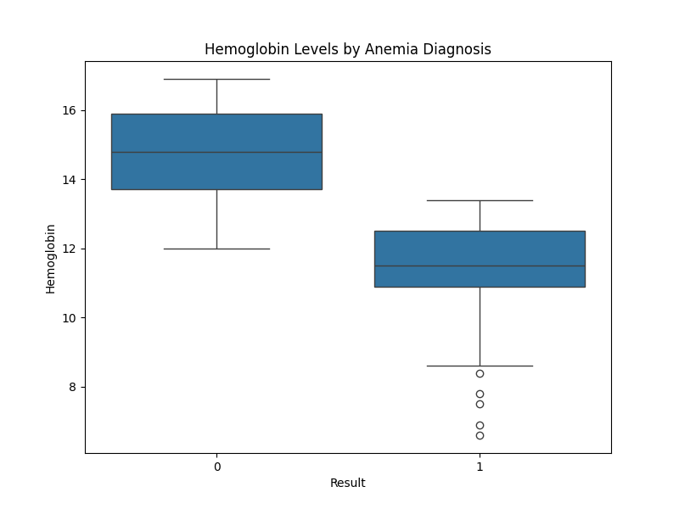

## Conclusion

The analysis highlights the importance of hemoglobin and iron levels in the diagnosis of anemia. The strong correlations observed in the dataset suggest potential pathways for further research, particularly in developing predictive models for anemia. The hypothesis testing reinforces the critical role of hemoglobin levels in clinical diagnosis, offering a valuable tool for medical professionals.

## Appendix

The visualizations and statistical analyses presented in this report provide a robust foundation for further investigation into the anemia dataset. Future work may explore more complex models and incorporate additional variables to enhance the predictive power and clinical relevance of the findings.